UNC Cancer Network Telehealth Oncology Lecture Series
Course Director: William A. Wood, MD, MPH

TOPIC | Breast Cancer Management in North Carolina: Updates for 2021 | DATE | 6/23/2021
SPEAKER | Yara Abdou, MD | AFFILIATION | UNC School of Medicine

Credit
The School of Medicine of The University of North Carolina at Chapel Hill is accredited by the Accreditation Council for Continuing Medical Education (ACCME) to provide continuing medical education for physicians. The School of Medicine of the University of North Carolina at Chapel Hill designates this live activity for a maximum of 1.0 AMA PRA Category 1 Credit(s)™. Physicians should claim only those hours of credit actually spent in the educational activity.

To receive credit for this activity, you must have a CME profile with UNC CPD. To check if you have a CME profile, go to www.med.unc.edu/cpd and click on the transcript link, then attempt to log in. If you don’t have a CME profile, or can’t access it, please contact Doug Hudson at douglas_hudson@med.unc.edu. You will not receive credit without a CME profile.

Disclosures
This activity is planned and implemented under the sole supervision of the above-named course director, in association with the Office of Continuing Professional Development (UNC CPD). William A. Wood, MD, MPH, and CPD staff have no relevant financial relationships with commercial interests as defined by the ACCME.

The speaker has no relevant financial relationships with commercial interests as defined by the ACCME.

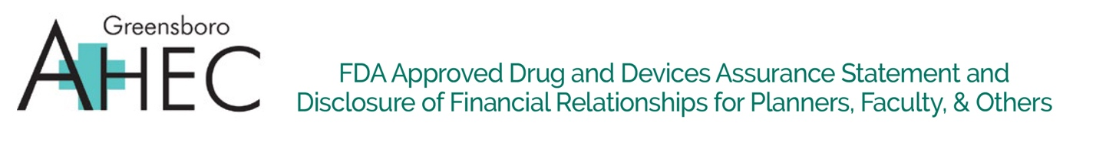

Breast Cancer Management  in North Carolina: Updates for 2021 | DATE: 6/23/2021  12:00 – 1:00 pm

Purpose:

80% of learners for this activity will self-report that they gained new knowledge related to breast cancer therapy that can be applied to patient care.

Learning Outcomes:
- Discuss recent advances in neoadjuvant and adjuvant systemic therapy approaches for patients with early-stage breast cancer.
- Discuss recent advances in systemic therapy for patients with advanced stage or metastatic breast cancer.
- Discuss the recent use of immunotherapy and targeted therapy in the management of breast cancer.

Requirements for Successful Completion of the Educational Activity

In order to successfully complete this activity, you must:
- Sign in at the registration table and verify that your email address is correct.
- Attend at least 50 minutes of the learning session and complete and submit the online evaluation within 7 days, in order to be awarded 1.0 contact-hour for this learning activity
- Save the certificate to your computer and print a hard-copy for your records when you have completed the evaluation. You have seven (7) days to submit this evaluation.

Conflicts of Interest/Disclosures
COI statement goes here.

Commercial Support
Commercial state goes here.

Greensboro AHEC and UNC Telehealth Joint Program
RESEARCH TO PRACTICE LECTURE (ROSTER)
Scan completed roster and submit via https://learn.unccn.org within 1 week of the lecture date.
Program Title: Breast Cancer Management in North Carolina: Updates for 2021
Date: 6/23/2021 |  | Location of Webinar:
Time Started: 12:00 pm | Time Ended: 1:00pm | Length of Program: 60 minutes
On-site Facilitator: |  | Activity Directors: William A. Wood, MD, MPH
Continuing Education Specialist: Jon Powell, PhD |  | Nurse Planner: Lisa Guy, RN, CCRN
AACME Disclosure Information:
Activity Directors: William A. Wood, MD, MPH, and CPD staff have no relevant financial relationships with commercial interests as defined by the ACCME.
Speaker(s): Yara Abdou, MD, has no relevant financial relationships with commercial interests as defined by the ACCME.

 | Title: (If "Other" write title) |  |  |  |  |  |  |  |  | Type of Credit: (Choose One)
Name (Print) | RN | LPN | AP RN | MD | DO | PA | RT | Other | Email (Please print clearly) | ASRT | CNPD/CNE

