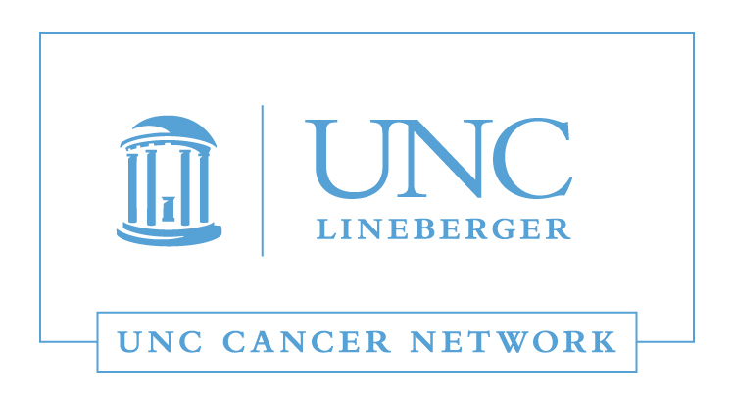

RN and Allied Health Lecture:
Management of Malignant Pain in the
Era of an Opioid Epidemic

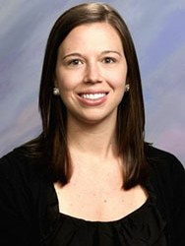 | Meredith D. Keisler, PharmD, BCOP, CPP  Clinical Pharmacist Practitioner  Supportive Care Consult Service  UNC Hospitals  University of North Carolina, Chapel Hill

It is estimated that over 50 percent of cancer patients will experience pain associated with their diagnosis, many of whom will require opioid therapy. According to the Center for Disease Control and Prevention, opioids, prescription and illicit, are the main driver of drug overdose deaths in the US. Between 2014-2015, there was a 14.5% increase in drug overdose death rates in North Carolina. This lecture will discuss management of pain in an oncology setting while considering risk factors for opioid abuse and addiction.

Learning Outcomes:

- Review the pathophysiology of pain.
- Explain the mechanisms of action of opioid and non-opioid analgesics.
- Compare and contrast characteristics of analgesics and their place in therapy.
- Recognize risk factors for opioid misuse.

This Telehealth Lecture will be broadcast using UNC telemedicine equipment on the UNC Cancer Network Learning Portal. Visit learn.unccn.org/ to register for this lecture.

LEARN MORE: unccn.org

UPCOMING EVENTS: unccn.org/events

The School of Nursing at the University of North Carolina at Chapel Hill is accredited as a provider of continuing nursing education by the American Nurses Credentialing Center's Commission on Accreditation.  To successfully complete this program and be awarded 1 ANCC contact hour you must attend at least 50 minutes of the seminar and complete the online evaluation. | The American Registry of Radiologic Technologists (ARRT) is a leading credentialing organization that  recognizes qualified individuals in medical imaging, interventional procedures, and radiation therapy.  This activity is worth 1 credit hour  and is pending approval by the ASRT.

 |  | facebook.com/unccn |  |  | @unc_cn

