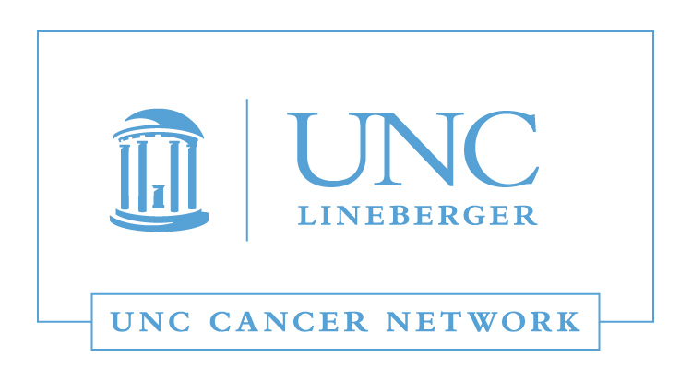

Medical and Surgical Oncology Lecture:
Immunotherapy Advances in Lung Cancer
Wednesday, February 21, 2018
12:00 - 1:00 P.M.

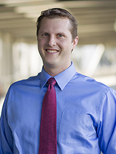 | Chad Pecot, MD  Assistant Professor  UNC School of Medicine  Lineberger Comprehensive Cancer Center  University of North Carolina, Chapel Hill

Learning Outcomes:

- To understand basic tumor immunology and concepts regarding use of the immune system to combat cancer.
- To describe current FDA approved immunotherapies in lung cancer.
- To outline some of the promising future directions in immunotherapy.

WHERE:  This Telehealth Lecture will be broadcast live using UNC telemedicine equipment, via WebEx, and via GoToWebinar. | HOW:  Visit www.unccn.org/events to register for this lecture, contact your Site Coordinator, or email: unccn@unc.edu

LEARN MORE: unccn.org

UPCOMING EVENTS: unccn.org/events

The School of Nursing at the University of North Carolina at Chapel Hill is accredited as a provider of continuing nursing education by the American Nurses Credentialing Center's Commission on Accreditation.  To successfully complete this program and be awarded 1 ANCC contact hour you must attend at least 50 minutes of the seminar and complete the online evaluation. | The American Registry of Radiologic Technologists (ARRT) is a leading credentialing organization that  recognizes qualified individuals in medical imaging, interventional procedures, and radiation therapy.  This activity is worth 1 credit hour and is pending approval by the ASRT. | The School of Medicine of the University of North Carolina at Chapel Hill is accredited by the Accreditation Council for Continuing Medical Education (ACCME) to provide continuing medical education for physicians.  The School of Medicine of the University of North Carolina at Chapel Hill designates this live activity for a maximum of 1.0 AMA PRA Category 1 Credit(s)™. Physicians should claim only the credit commensurate with the extent of their participation in the activity.

 |  | facebook.com/unccn |  |  | @unc_cn

