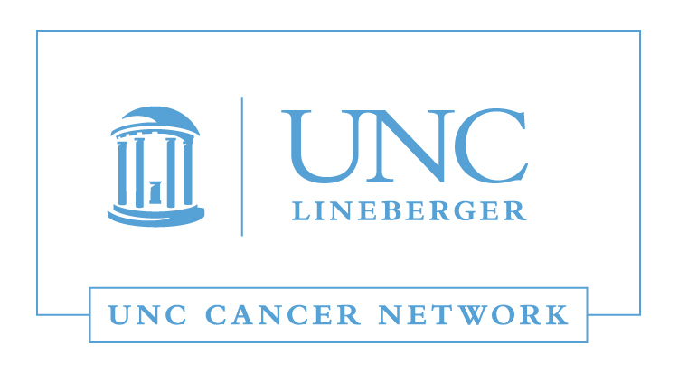

Medical and Surgical Oncology Lecture:
Metastatic Breast Cancer 2017
Wednesday, December 13, 2017
12:00 - 1:00 P.M.

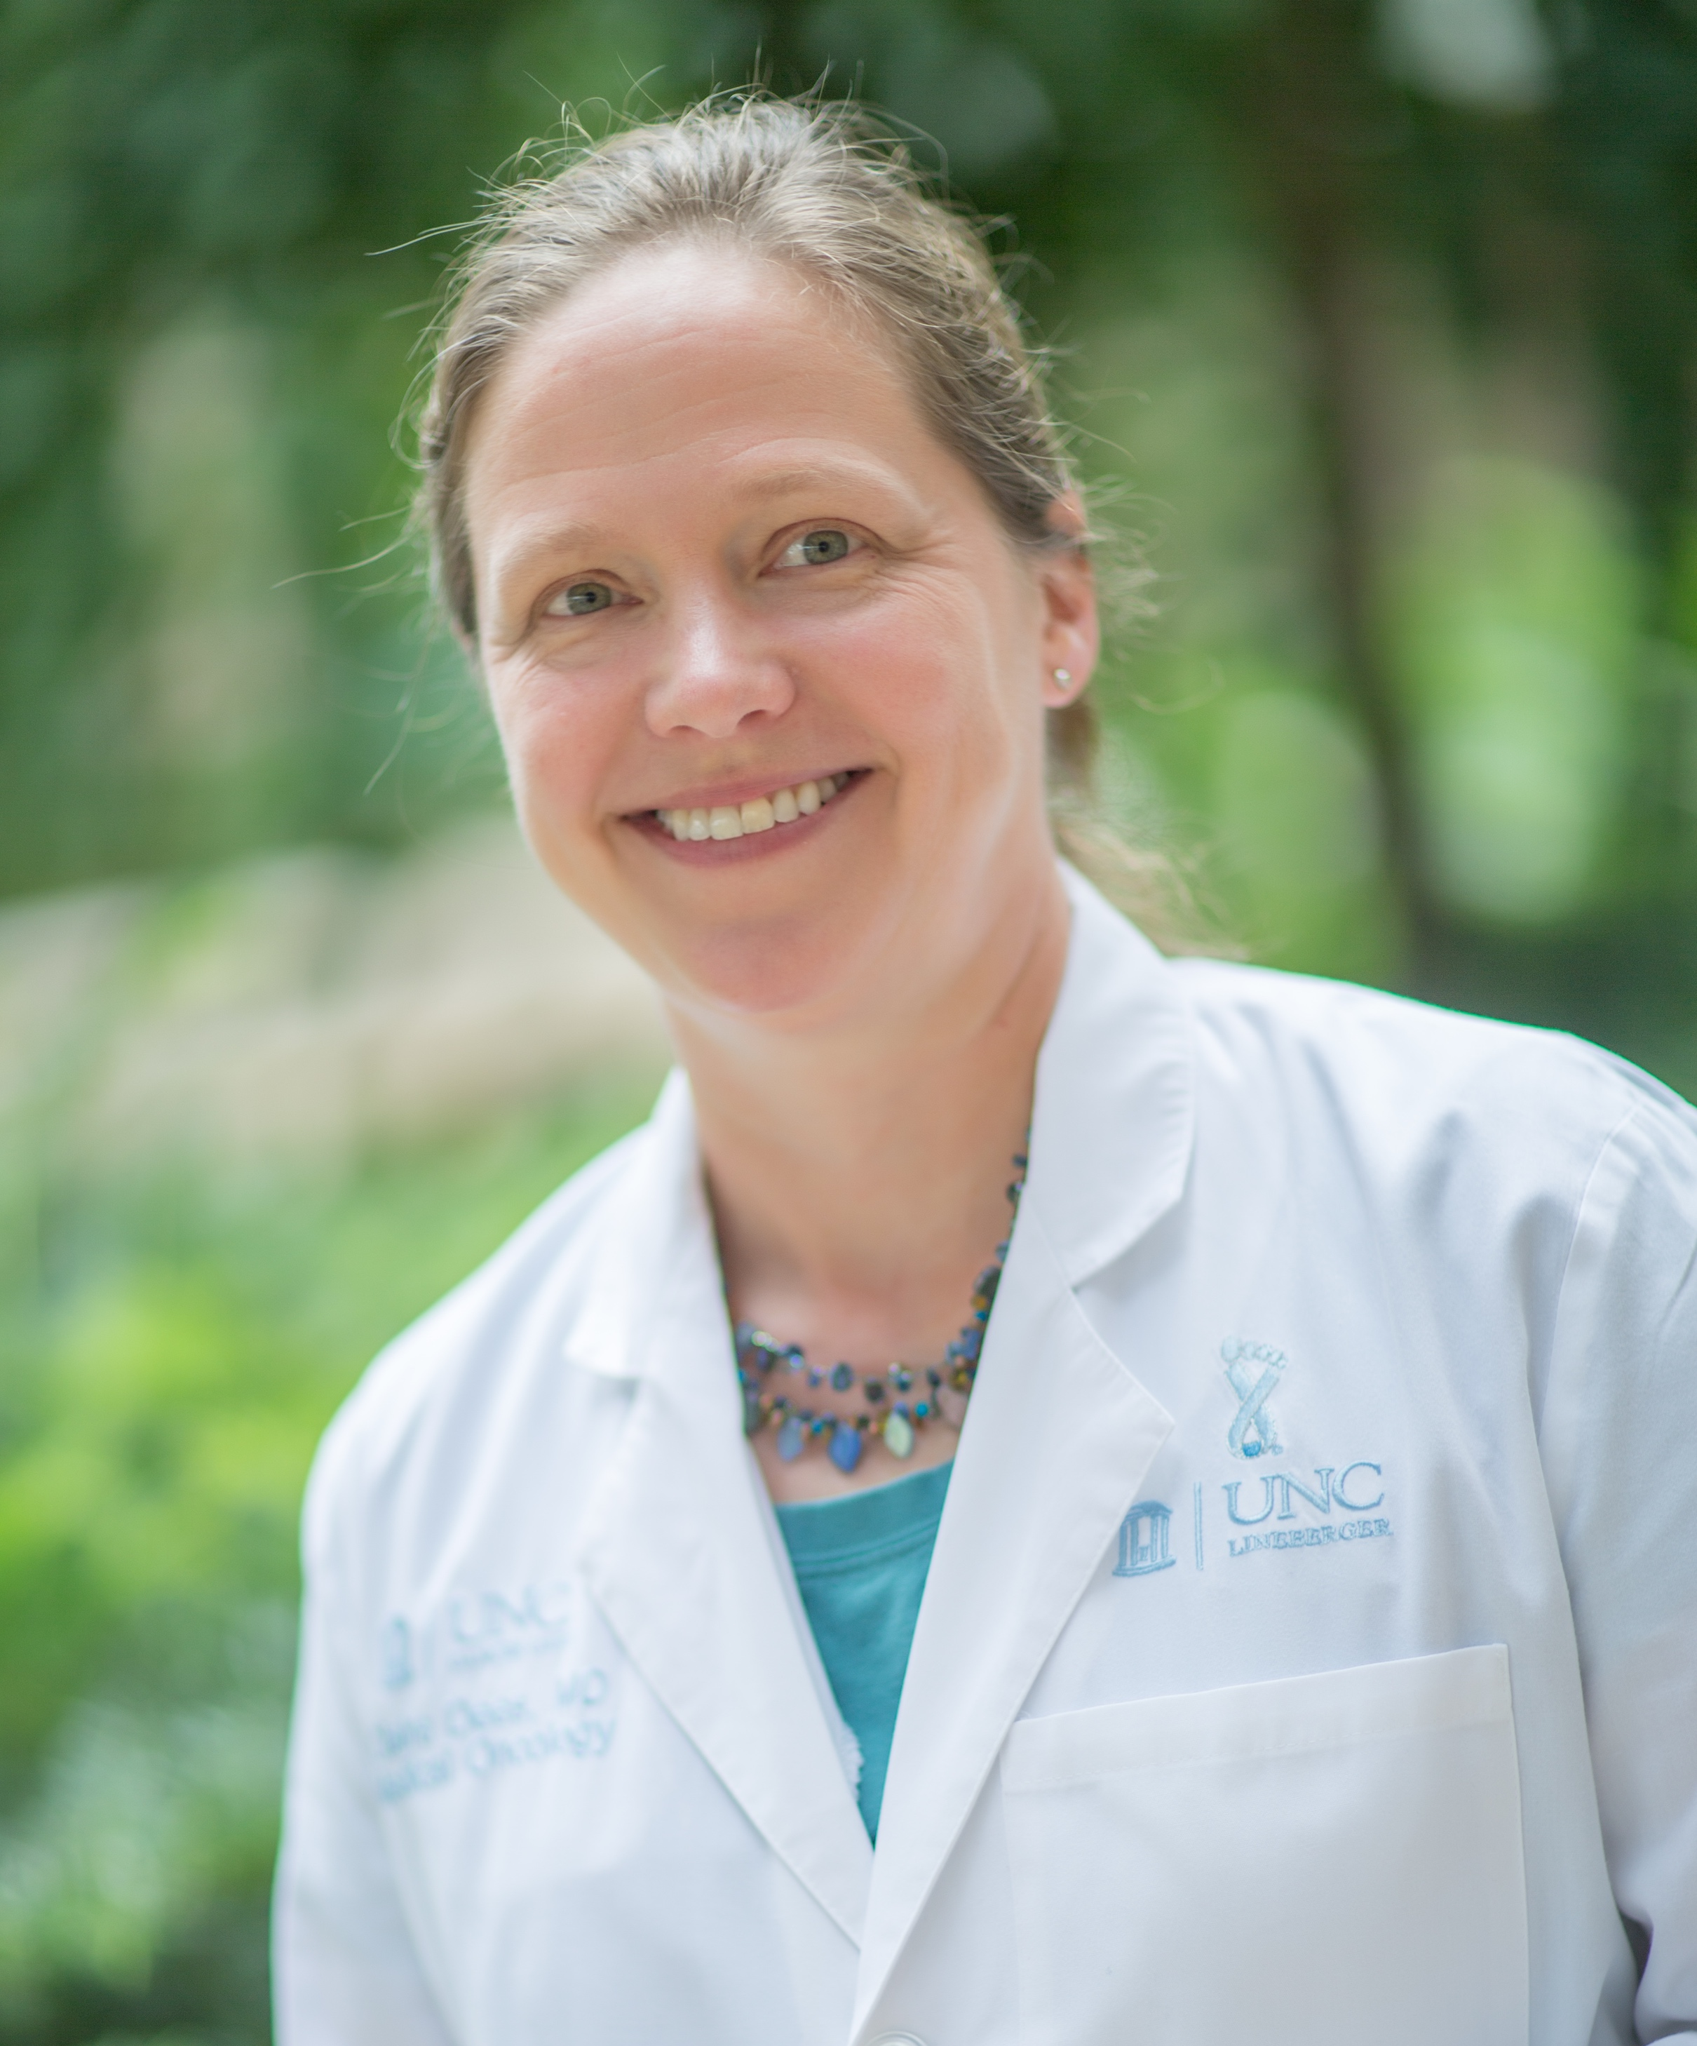 | Claire Dees, MD  Professor  Breast Cancer and Clinical Research  School of Medicine  Lineberger Comprehensive Cancer Center  University of North Carolina, Chapel Hill

Learning Outcomes:

- Understand systemic therapy options for HR+Her2- Metastatic Breast Cancer (MBC).
- Understand systemic therapy options for Her2+ MBC.
- Understand systemic therapy options for triple negative MBC.

WHERE:  This Telehealth Lecture will be broadcast live using UNC telemedicine equipment, via WebEx, and via GoToWebinar. | HOW:  Visit www.unccn.org/events to register for this lecture, contact your Site Coordinator, or email: unccn@unc.edu

LEARN MORE: unccn.org

UPCOMING EVENTS: unccn.org/events

  The School of Nursing at the University of North Carolina at Chapel Hill is accredited as a provider of continuing nursing education by the American Nurses Credentialing Center's Commission on Accreditation.
  To successfully complete this program and be awarded 1 ANCC contact hour you must attend at least 50 minutes of the seminar and complete the online evaluation.
  The School of Medicine of the University of North Carolina at Chapel Hill is accredited by the Accreditation Council for Continuing Medical Education (ACCME) to provide continuing medical education for physicians.
  The School of Medicine of the University of North Carolina at Chapel Hill designates this live activity for a maximum of 1.0 AMA PRA Category 1 Credit(s)™. Physicians should claim only the credit commensurate with the extent of their participation in the activity.

Approved by the ASRT for 1 Category A continuing education credit.

 |  | facebook.com/unccn |  |  | @unc_cn

