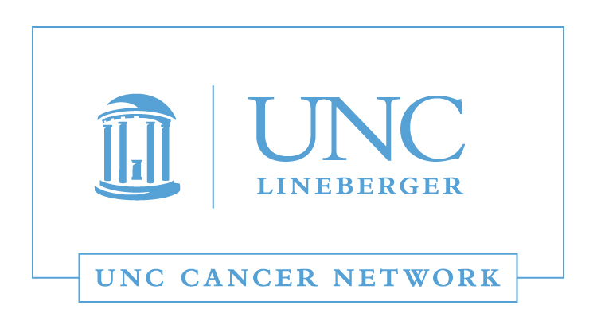

RN and Allied Health Lecture:
The Evidence Base for
Integrative Approaches to Cancer Care
Wednesday, December 6, 2017
12:00 - 1:00 P.M.

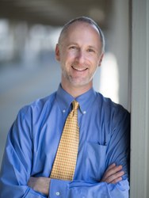 | Gary Asher, MD, MPH  Assistant Professor  School of Medicine  Director of Integrative Medicine Services  UNC Lineberger Comprehensive Cancer Center  University of North Carolina, Chapel Hill

Learning Outcomes:

- Identify terms and therapies associated with complementary and alternative medicine.
- Describe the patterns of CAM therapy use within the cancer population.
- Identify evidence-based CAM therapies for oncology.

WHERE:  This Telehealth Lecture will be broadcast live using UNC telemedicine equipment, via WebEx, and via GoToWebinar. | HOW:  Visit www.unccn.org/events to register for this lecture, contact your Site Coordinator, or email: unccn@unc.edu

LEARN MORE: unccn.org

UPCOMING EVENTS: unccn.org/events

The School of Nursing at the University of North Carolina at Chapel Hill is accredited as a provider of continuing nursing education by the American Nurses Credentialing Center's Commission on Accreditation.

To successfully complete this program and be awarded 1 ANCC contact hour you must attend at least 50 minutes of the seminar and complete the online evaluation.

Approved by the ASRT for 1 Category A continuing education credit.

 |  | facebook.com/unccn |  |  | @unc_cn

