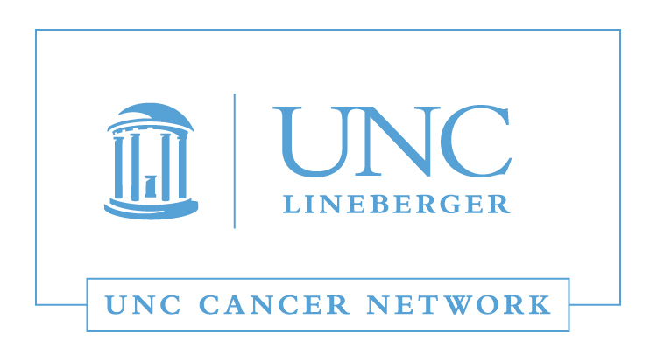
RN and Allied Health Lecture:
The Role of Palliative Care and Hospice Care
in Improving Quality of Life
Wednesday, November 8, 2017
12:00 - 1:00 P.M.

 | Gary Winzelberg, MD, MPH  Associate Professor  Division of Geriatric Medicine,  Palliative Care Program  Director, Hospice and Palliative Medicine Fellowship Program  School of Medicine  University of North Carolina, Chapel Hill

Learning Outcomes:

- Discuss the historical developments associated with the development of hospice and palliative care services.
- Identify the common features and distinctions between hospice and palliative care.
- Describe the evidence demonstrating the impact of palliative care on the quality of life for seriously ill patients.

WHERE:  This Telehealth Lecture will be broadcast live using UNC telemedicine equipment, via WebEx, and via GoToWebinar. | HOW:  Visit www.unccn.org/events to register for this lecture, contact your Site Coordinator, or email: unccn@unc.edu

LEARN MORE: unccn.org

UPCOMING EVENTS: unccn.org/events

The School of Nursing at the University of North Carolina at Chapel Hill is accredited as a provider of continuing nursing education by the American Nurses Credentialing Center's Commission on Accreditation.

To successfully complete this program and be awarded 1 ANCC contact hour you must attend at least 50 minutes of the seminar and complete the online evaluation.

Approved by the ASRT for 1 Category A continuing education credit.

 |  | facebook.com/unccn |  |  | @unc_cn

