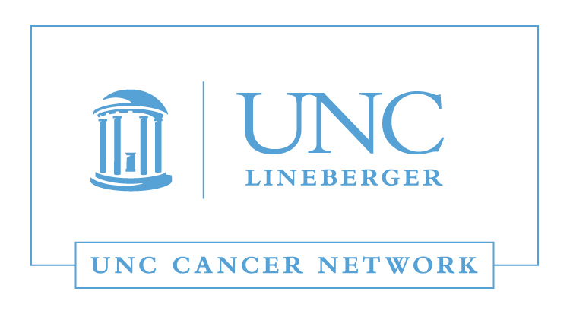

Medical and Surgical Oncology Lecture:

Advances in Melanoma Cancer Treatment

Wednesday, November 15, 2017

12:00 - 1:00 P.M.

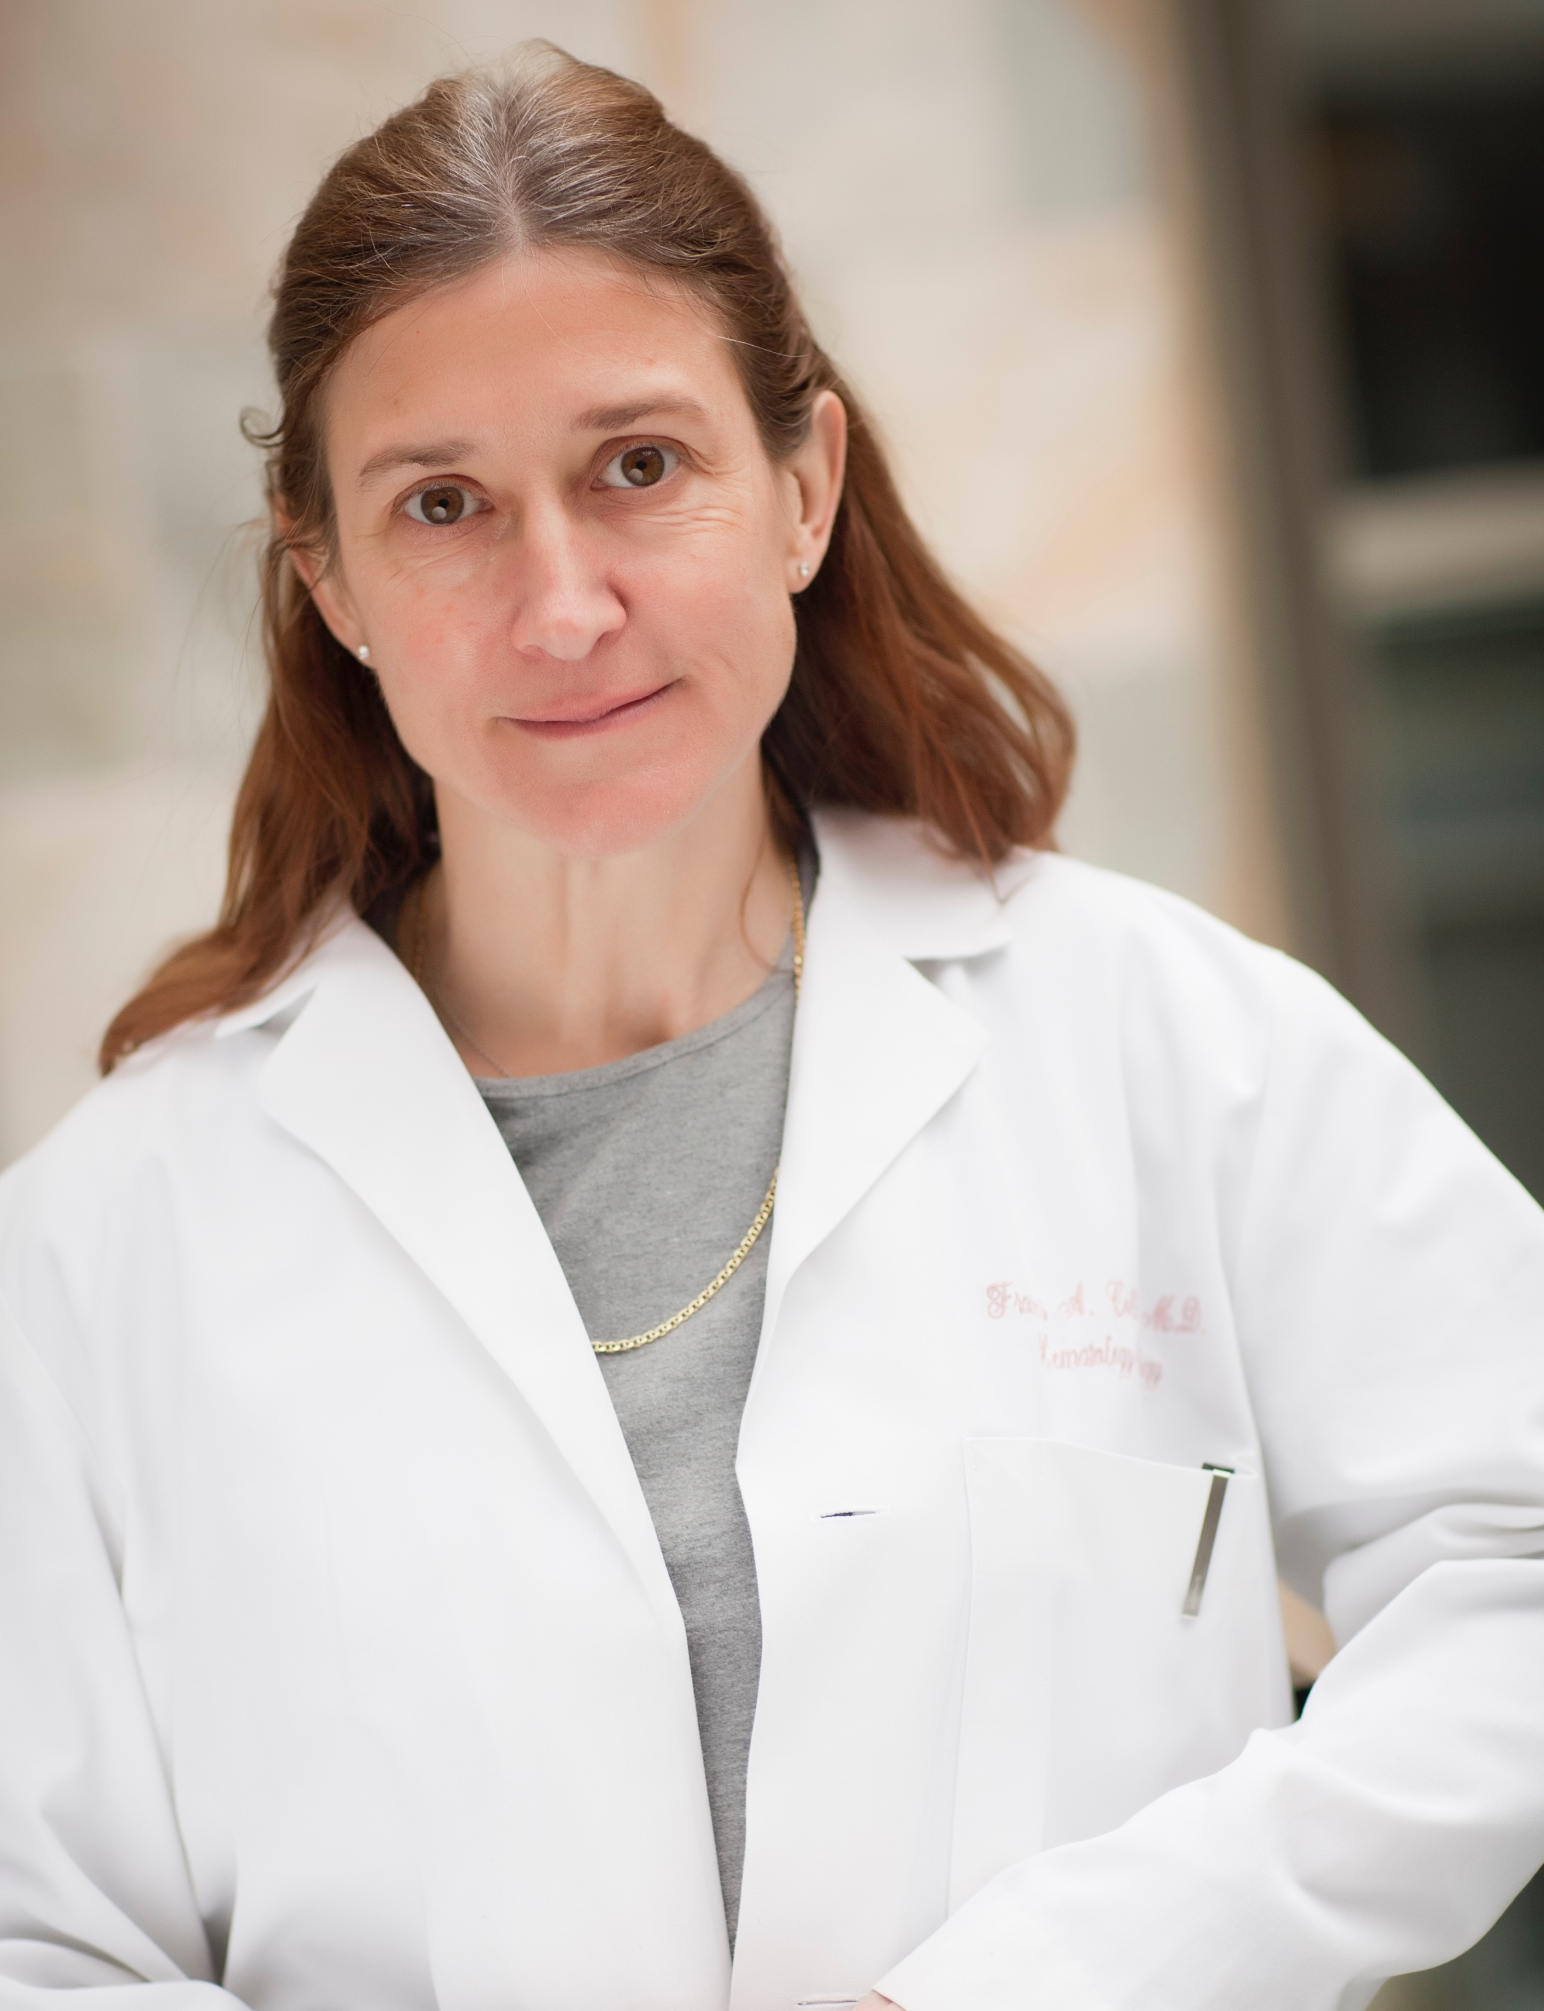 | Frances Collichio, MD  Professor of Medicine  Division of Hemetology/Oncology  UNC School of Medicine  Lineberger Comprehensive Cancer Center  University of North Carolina, Chapel Hill

Learning Outcomes:

- Review the ABCDEs for melanoma.
- Know the standard of care for each stage of disease including the new treatments for stage III.
- Know how to recognize the side effects of therapy.

WHERE:  This Telehealth Lecture will be broadcast live using UNC telemedicine equipment, via WebEx, and via GoToWebinar. | HOW:  Visit www.unccn.org/events to register for this lecture, contact your Site Coordinator, or email: unccn@unc.edu

LEARN MORE: unccn.org

UPCOMING EVENTS: unccn.org/events

  The School of Nursing at the University of North Carolina at Chapel Hill is accredited as a provider of continuing nursing education by the American Nurses Credentialing Center's Commission on Accreditation.
  To successfully complete this program and be awarded 1 ANCC contact hour you must attend at least 50 minutes of the seminar and complete the online evaluation.
  The School of Medicine of the University of North Carolina at Chapel Hill is accredited by the Accreditation Council for Continuing Medical Education (ACCME) to provide continuing medical education for physicians.
  The School of Medicine of the University of North Carolina at Chapel Hill designates this live activity for a maximum of 1.0 AMA PRA Category 1 Credit(s)™. Physicians should claim only the credit commensurate with the extent of their participation in the activity.

Approved by the ASRT for 1 Category A continuing education credit.

 |  | facebook.com/unccn |  |  | @unc_cn

